**Earthquake prediction model using python**

**Introduction:**

Earthquakes are natural disasters that can have devastating effects on communities, infrastructure, and the environment. The ability to predict when and where earthquakes will occur has long been a goal of scientists and researchers. While we cannot yet forecast earthquakes with pinpoint accuracy, significant progress has been made in the field of earthquake prediction**.**

One of the key aspects of advancing earthquake prediction is the use of visualization techniques. Visualization plays a crucial role in understanding complex data, patterns, and trends related to seismic activity. By creating visual representations of seismic data, researchers and decision-makers can gain valuable insights into earthquake prediction and preparedness.

**Visualization:**

Visualization is a powerful technique for representing complex data, patterns, and information in a graphical or visual format. It involves using charts, graphs, maps, images, and other visual aids to make data more understandable and accessible to a wide range of users. Visualizing data on a world map is a powerful way to convey geographic patterns, trends, and insights. There are various techniques and tools available for this purpose, depending on the nature of your data and your specific objectives.

**Exploratory data analysis:**

Certainly, here's content focused on Exploratory Data Analysis (EDA) without a list of steps or key points:

Exploratory Data Analysis (EDA) is a fundamental practice in data analysis that aims to understand the structure and characteristics of a dataset. EDA helps analysts uncover insights, detect anomalies, and identify patterns within the data. It is a crucial phase that informs subsequent data processing and modeling. In EDA, the primary objective is to let the data speak for itself, revealing its inherent qualities and quirks.

EDA often starts with the collection of data from various sources. Once the data is in hand, it's time to clean and prepare it. Data cleaning involves dealing with missing values, handling duplicates, and addressing outliers. This process ensures that the data is reliable and accurate, forming a solid foundation for analysis.

**Dataset:**

The following database can be used for the earthquake prediction model using the python code. The following dataset can be taken from the kaggle website. It can very useful for the earthquake prediction. This can used to research ,analysis and also data-driven decision making.

**Dataset link:**[**https://www.kaggle.com/datasets/usgs/earthquake-database**](https://www.kaggle.com/datasets/usgs/earthquake-database)

The data collection and preprocessing can be already done in the phase 3. The dataset can be analyse and also the steps of data cleaning and remove some outliers or any other irrelevant from the dataset . And then the earthquake prediction model begin building is also done in the phase 3. In this phase, visualization of the earthquake prediction in world map can be executed below.

**Program :**

import numpy as np

import pandas as pd

import matplotlib.pyplot as plt

from mpl_toolkits.basemap import Basemap

import os

data = pd.read_csv('/content/database.csv.zip')

magnitudes = data['Magnitude']

import plotly.express as px

import pandas as pd

# Import data from USGS

data = pd.read_csv('https://earthquake.usgs.gov/earthquakes/feed/v1.0/summary/all_month.csv')

# Drop rows with missing or invalid values in the 'mag' column

data = data.dropna(subset=['mag'])

data = data[data.mag >= 0]

# Create scatter map

fig = px.scatter_geo(data, lat='latitude', lon='longitude', color='mag',

                     hover_name='place', #size='mag',

                     title='Earthquakes Around the World')

fig.show()

**output:**

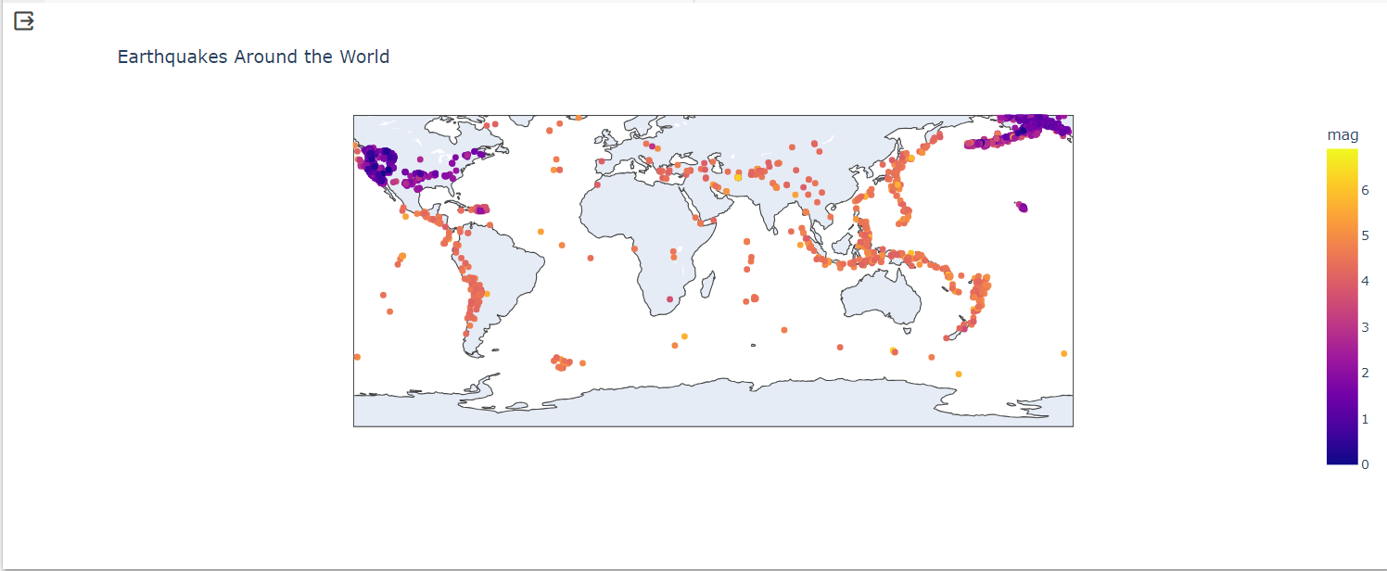

Now Splitting the data into training and testing sets for test and predict the earthquake .

import pandas as pd

from sklearn.linear_model import LinearRegression

from sklearn.model_selection import train_test_split

df = pd.read_csv('/content/database.csv.zip')

X = df.iloc[:, :-1]

y = df.iloc[:, -1]

# split the dataset

X_train, X_test, y_train, y_test = train_test_split(X, y, test_size=0.05, random_state=2)

y_train

**output:**

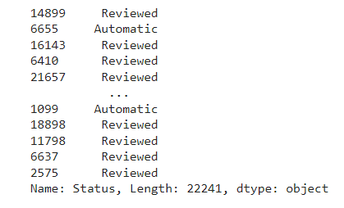

X_train

**Output:**

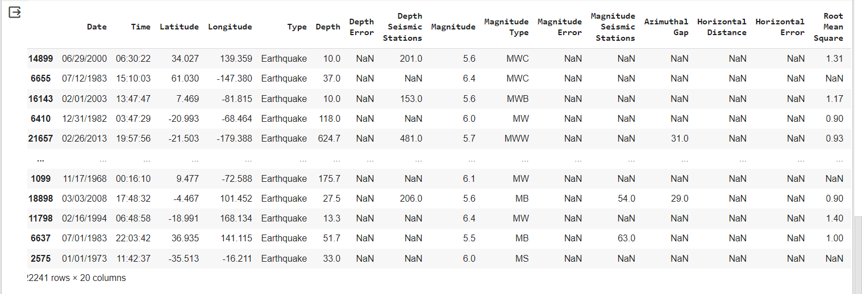

**Conclusion:**

In conclusion, the visualization of earthquake prediction plays a pivotal role in enhancing our understanding of seismic activity and equipping us with the tools to mitigate the impact of these natural disasters. Through the power of visual representation, we can better comprehend complex patterns, make informed decisions, and educate the public on earthquake awareness and preparedness.

The ability to analyze seismic data visually has provided researchers with the means to detect patterns, anomalies, and potential precursors to earthquakes. It helps us unravel the intricacies of geological factors that contribute to seismic events. By creating real-time early warning systems and using interactive visualizations, we can provide communities with the precious seconds needed to prepare and seek safety.